GECRXpress ISSUE Management

Date:03.09.2107

1. No navigation function to brows another page.

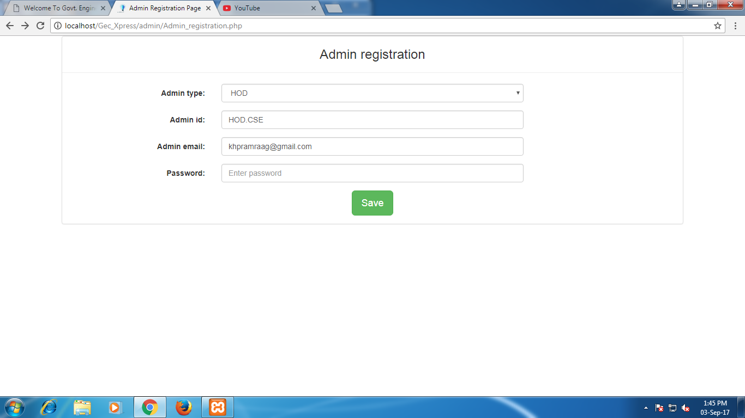  
2. Unable to view respective departmental news by sorting

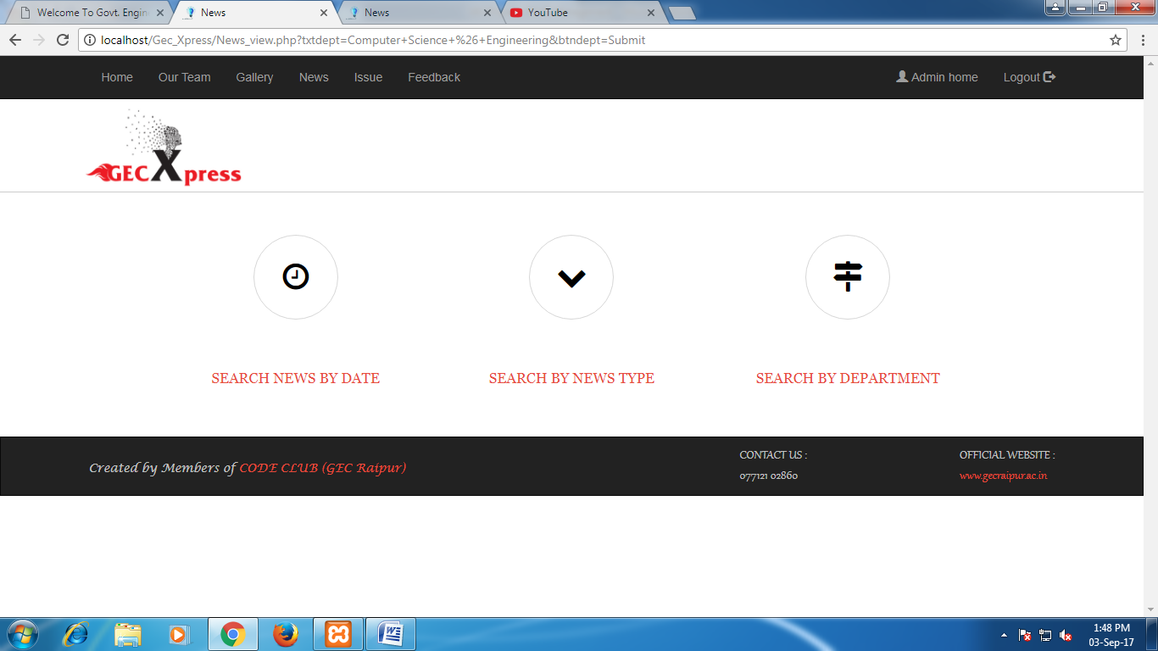

Scenario Computer Science News

1. Testing with date where no news was existing,
   1. Expected: system supposed to be alert saying no such news.
   2. Actual: But system does not alert.

Result: Fail

1. Testing for news can be edited by other than a person who uploaded.
   1. Expected: System should not allow to edit other the person who uploaded.
   2. Actual: System allowing to edit.

Result: Fail.

1. Mailing mechanism, not enable.
2. Phone mechanism(SMS etc), not enable.
3. Test to check the status changes. Not working

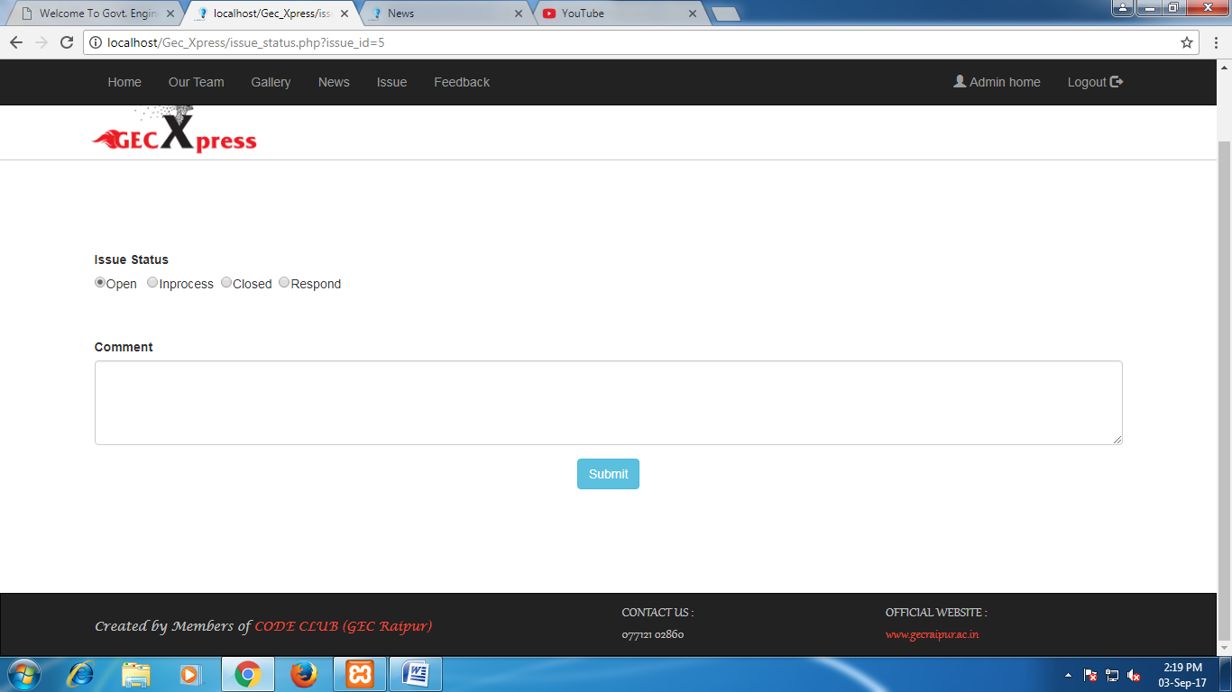

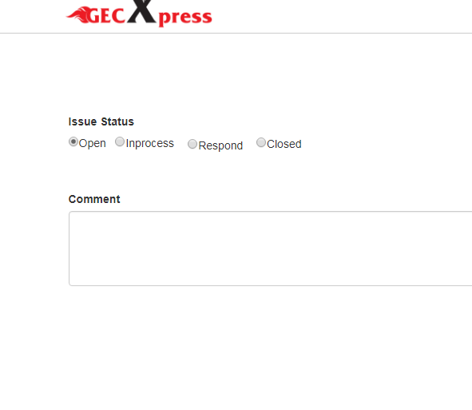Modified Issue tracking